

**A Project Report On**

**AUTOMATION TESTING ON TEA COMPANY**

**By**

**Mayuri M. Pol**

**Batch: (2021-5765)**

**Course: School of Coding-Certified Software Test Engineer**

**Under the Guidance of,**

**Priyanka Desale**

**(Technical Trainer)**

**EduBridge**

**INTRODUCTION**

This Project aims to do overall testing like functional testing, Non-Functional testing, and performance of that website also to check quality of application. It helps to improve quality of website and saves time for manually doing this testing. In this project our main aim is to check functionalities available on website. Also, it includes title check, all elements and all links with their working status.

**SOFTWARE REQUIREMENTS**

• Operating System: Windows 10

• Browser: Latest version of Chrome

• IDE: Eclipse IDE

• Automation Tool: Selenium WebDriver

• Front-end: Java

**TC01-** **Launch the browser and open URL.**

System.setProperty ("webdriver.chrome.driver", "C:\\Users\\Admin\\ Desktop\\Selenium Jar\\Chromedriver.exe");

WebDriver w=new ChromeDriver ();

w.get ("https://www.practiceselenium.com/");

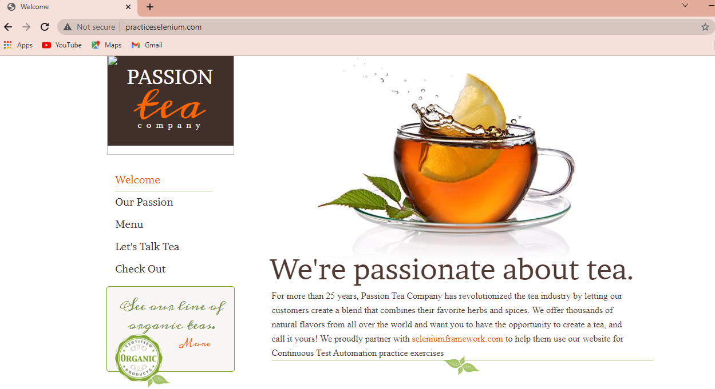

**TC02-To check the functionality of welcome Button**

w.findElement (By.linkText (“Welcome”)).click ();

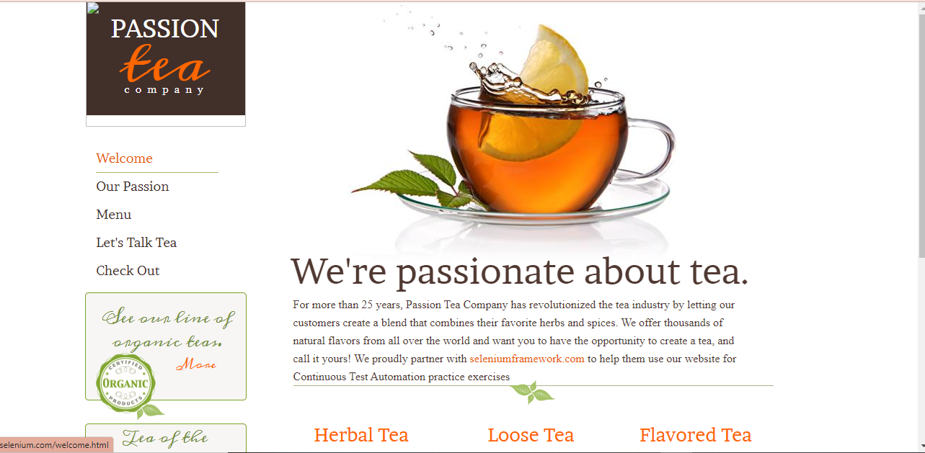

**TC03-To Check the functionality of check out Button**

w.findElement (By.linkText (“see collection”)).click();

Thread.sleep (2000);

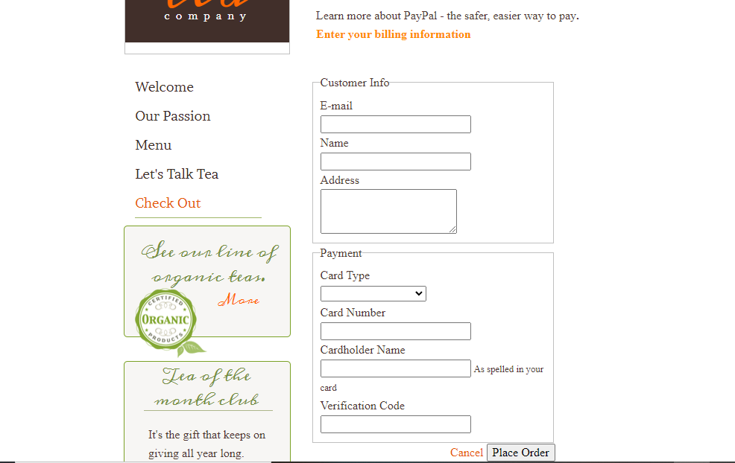

**TC04-To Check the Functionality of Place Order Button with Selecting Visa from dropdown**

w.findElement (By.id (“email”)).send keys (“test”);

w.findElement (By.id (“name”)).send keys (“test”);

w.findElement (By.id (“address”)).send keys (“test”);

selects21=new

Select (w.findElement (By.id (“card type”)));

S21.selectByVisible Text (“visa”);

w.findElement (By.id (“card number”)).send keys (“test”);

w.findElement (By.id (“cardholder number”)).send keys (“test”);

w.findElement (By.id (“verification code”)).send keys (“test”);

w.findElement (By.Path (“//*[@id=\”wsb-element-00000000-0000-0000-0000-000452010925\”]/div/div/form/div/button”)).click();

Defect :- Selecting visa from drop down and filling all text field with test as a data. After click on Place order button it redirect to wrong page(Menu Page).

**TC05-To Check the Functionality of Place Order Button with selecting mastercard dropdown**

w.findElement (By.id (“email”)).send keys (“test”);

w.findElement (By.id (“name”)).send keys (“test”);

w.findElement (By.id (“address”)).send keys (“test”);

selects23=new

Select (w.findElement (By.id (“card type”)));

s23.selectByVisible (“MasterCard”);

w.findElement (By.id (“card_number”)).sendkeys(“test”);

w.findElement (By.id (“cardholder_number”)).sendkeys(“test”);

w.findElement (By.id (“verification_code”)).sendkeys(“test”);

w.findElement(By.xpath(“//*[@id=\”wsb-element-00000000-0000-0000-0000-000452010925\”]/div/div/form/div/button”)).click();

# 

Defect :- Selecting Mastercard from drop down and filling all text field with Blank data. After click on Place order button it redirect to wrong page(Menu Page).

**TC06-To check the functionality of Place Order Button with selecting American Express from Dropdown**

w.findElement(By.id(“email”)).sendkeys(“test”);

w.findElement(By.id(“name”)).sendkeys(“test”);

w.findElement(By.id(“address”)).sendkeys(“test”);

selects23=new

select(w.findElement(By.id(“card_type”)));

s23.selectByVisible Text(“Mastercard”);

w.findElement(By.id(“card_number”)).sendkeys(“test”);

w.findElement(By.id(“cardholder_number”)).sendkeys(“test”);

w.findElement(By.id(“verification_code”)).sendkeys(“test”);

w.findElement(By.xpath(“//*[@id=\”wsb-element-00000000-0000-0000-0000-000452010925\”]/div/div/form/div/button”)).click();

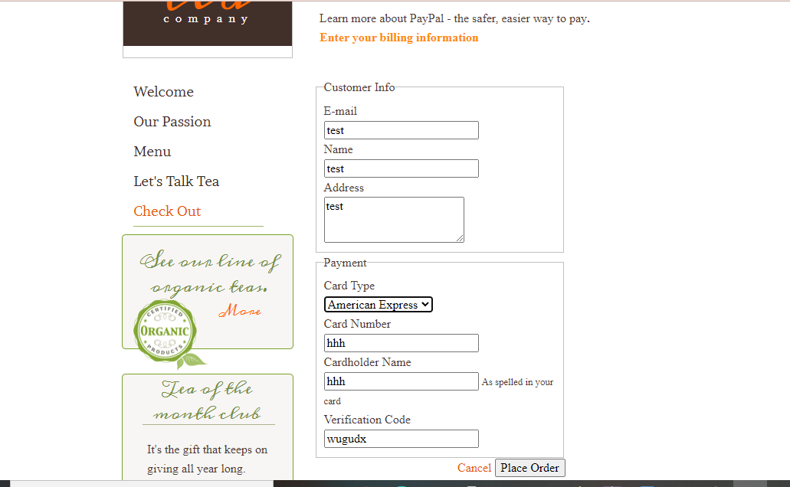

Defect :- Selecting American Express from drop down and filling all text field with Blank data. After click on Place order button it redirect to wrong page(Menu Page).

**TC07-To check the functionality of Place Order Button with selecting Diners club from Dropdown**

w.findElement(By.id(“email”)).sendkeys(“test”);

w.findElement(By.id(“name”)).sendkeys(“test”);

w.findElement(By.id(“address”)).sendkeys(“test”);

selects23=new

select(w.findElement(By.id(“card_type”)));

s23.selectByVisible Text(“Mastercard”);

w.findElement(By.id(“card_number”)).sendkeys(“test”);

w.findElement(By.id(“cardholder_number”)).sendkeys(“test”);

w.findElement(By.id(“verification_code”)).sendkeys(“test”);

w.findElement(By.xpath(“//*[@id=\”wsb-element-00000000-0000-0000-0000-000452010925\”]/div/div/form/div/button”)).click();

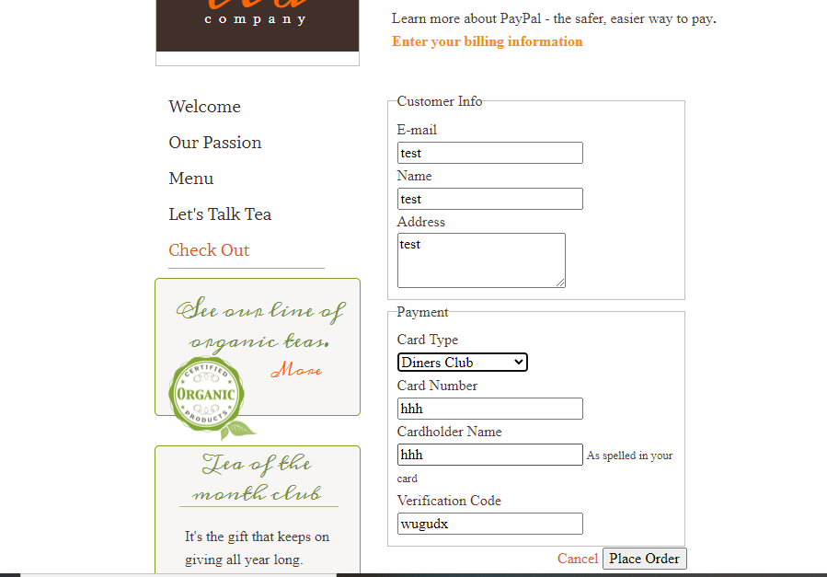

Defect :- Selecting Diners club from drop down and filling all text field with Blank data. After click on Place order button it redirect to new page(Menu Page).

**TC08-To back the welcome page**

w.navigate().back();

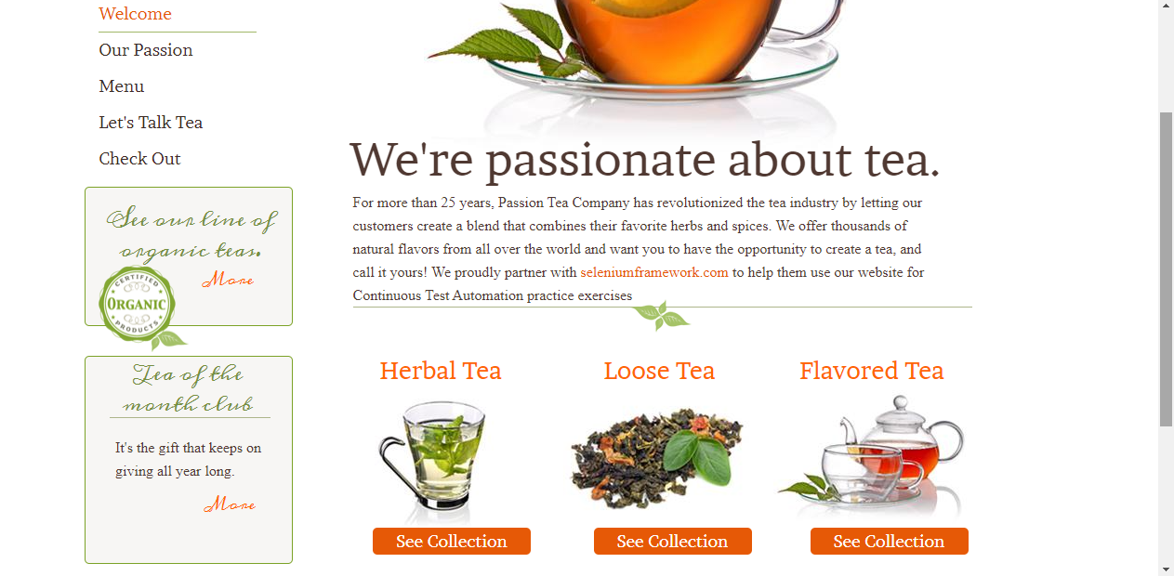

TC09:- To check the functionality of Let’s talk tea

w.findElement(By.linkText("Let's Talk Tea")).click();

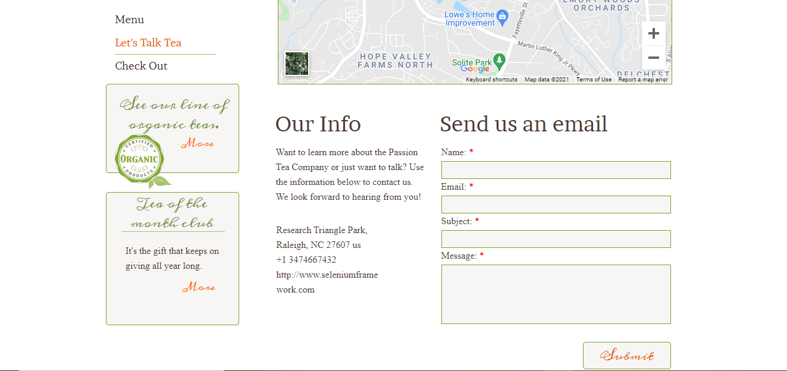

TC10:- To check the functionality of Submit Button

w.findElement(By.name("name")).sendKeys("test");

w.findElement(By.name("email")).sendKeys("test"); w.findElement(By.name("subject")).sendKeys("test");

w.findElement(By.name("message")).sendKeys("test"); Thread.sleep(2000);

//click on submit button.



**Defect:Submit button is not clickable**

TC11:To check functionality of Place Order for Check Out

w.findElement(By.linkText("Check Out")).click(); w.findElement(By.id("email")).sendKeys("test"); w.findElement(By.id("name")).sendKeys("test");

w.findElement(By.id("address")).sendKeys("test");

Select s43=new Select(w.findElement(By.id("card_type"))); s43.selectByVisibleText("Visa"); w.findElement(By.id("card_number")).sendKeys("test");

w.findElement(By.id("cardholder_name")).sendKeys("test");w.findElement(By.id("verification_code")).sendKeys("test"); w.findElement(By.xpath("//*[@id=\"wsb-element-00000000-0000-0000-0000-000452010925\"]/div/div/form/div/button")).click();

Thread.sleep(2000);



**Defect:- With blank, invalid and valid data Place Order button clickable and it redirect to Wrong page (Menu page).**

TC12:To check functionality of Cancle for Check Out

w.findElement(By.linkText("Check Out")).click(); w.findElement(By.id("email")).sendKeys("test"); w.findElement(By.id("name")).sendKeys("test");

w.findElement(By.id("address")).sendKeys("test");

Select s43=new Select(w.findElement(By.id("card_type"))); s43.selectByVisibleText("Visa"); w.findElement(By.id("card_number")).sendKeys("test");

w.findElement(By.id("cardholder_name")).sendKeys("test");w.findElement(By.id("verification_code")).sendKeys("test"); w.findElement(By.xpath("//*[@id="wsb-element-00000000-000000452010925"]/div/div/form/div/a")).click();

Thread.sleep(2000);



Defect:-When click on Cancle button it redirect to wrong page (Menu page).

TC13- Click on More button

w.findElement(By.*xpath*("//*[@id=\"wsb-element-00000000-0000-0000-0000-000450914883\"]/div/p/a/span")).click();

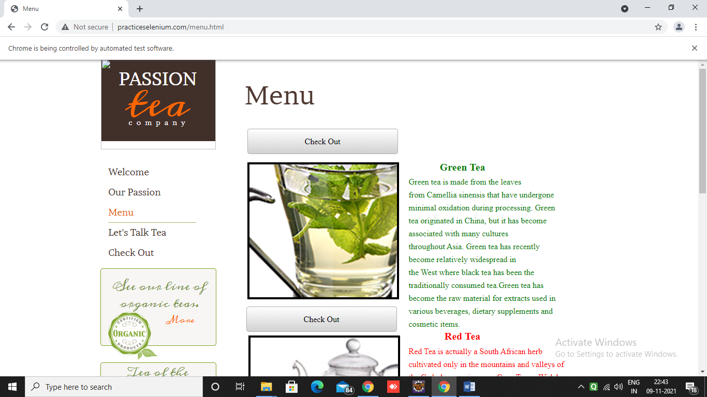

TC14- Click on Tea of the month club More Button

w.findElement(By.*xpath*("//*[@id=\"wsb-element-00000000-0000-0000-0000-000450914882\"]/div/p/a/span")).click();

